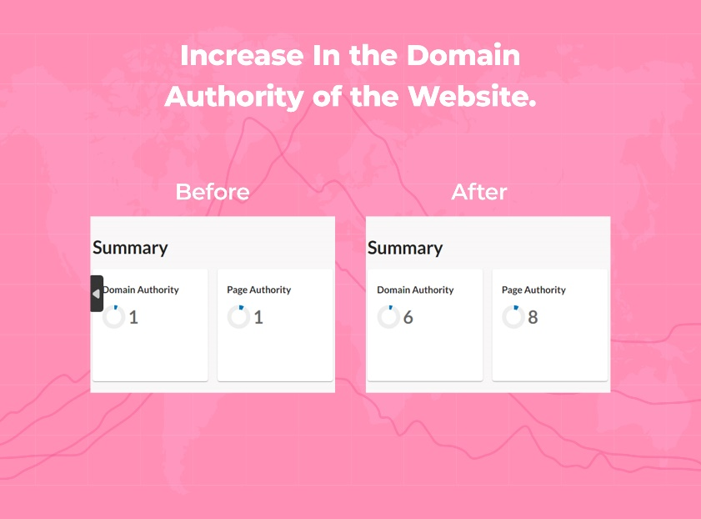

**Before:** The client's website had a Domain Authority and Page Authority of 1, with limited recognition and visibility. It struggled to attract organic traffic and establish prominence in search engine results.

**After:** Targeted SEO methods significantly improved the website's credibility, influence, and visibility. The Domain Authority increased to 6, and the Page Authority rose to 8, resulting in higher rankings and increased organic traffic.

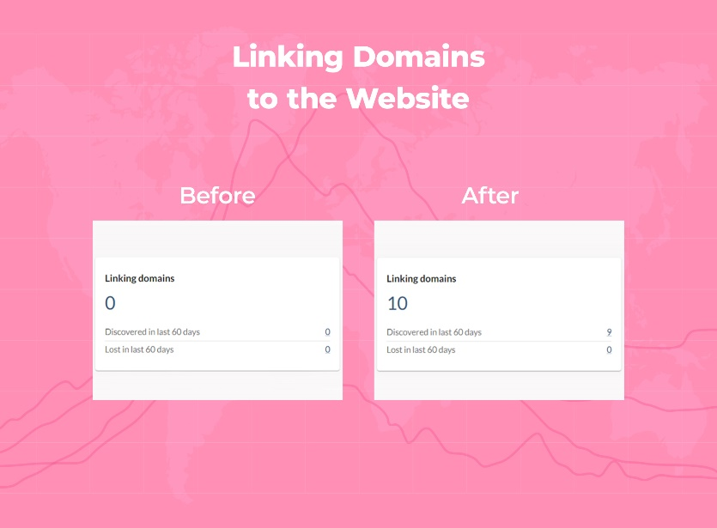

**Before:** The website lacked external linking domains, hampering referral traffic and search engine visibility, thereby limiting its online presence.

**After:** Implementing SEO strategies resulted in the acquisition of approximately 10 linking domains, enhancing the website's authority, credibility, and relevance in search engine rankings.

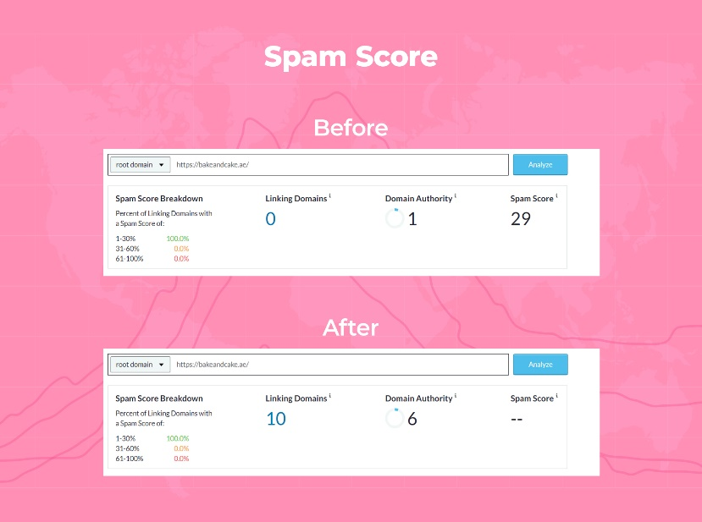

**Before:** The website had a spam score of 29, indicating the presence of potentially spammy or low-quality elements, compromising its credibility and visibility in search engine algorithms.

**After:** Through SEO efforts, the website achieved a spam score of 0, eliminating spam-related elements and improving its trustworthiness, credibility, and online reputation.

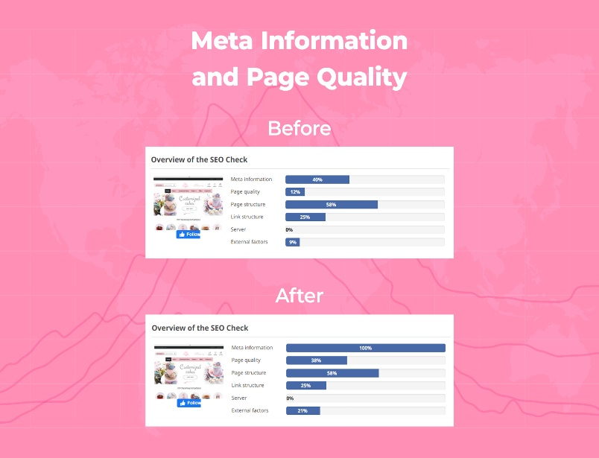

**Before:** The website had suboptimal Meta Information (40%), low Page Quality (12%), moderate Page Structure (58%), and insufficient Link Structure (25%). External Factors were modest at 9%.

**After:** Following SEO implementation, the Meta Information improved to 100%, Page Quality increased to 38%, Page Structure remained at 58%, and Link Structure showed no significant change at 25%. External Factors remained unchanged at 9%.

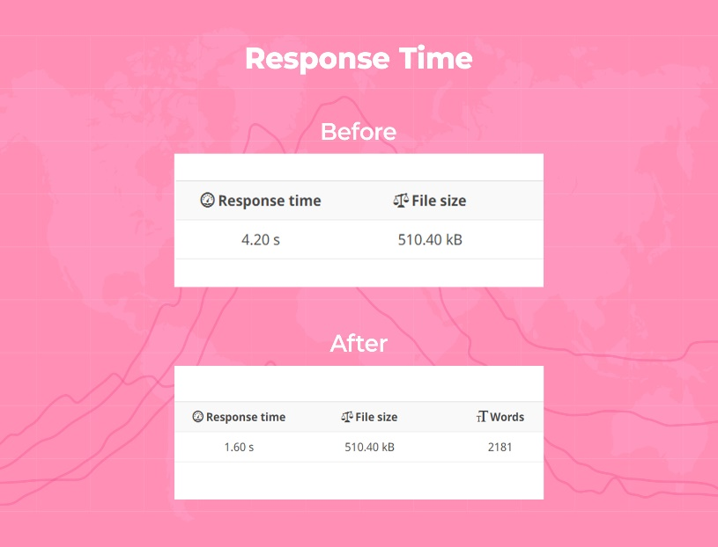

**Before:** The website exhibited a response time of 4.20 seconds for a 500 kb file size, indicating a relatively slow loading speed that could potentially impact user experience and engagement.

**After:** After implementing SEO, the website's response time significantly improved to 1.60 seconds for the same 500 kb file size, resulting in a faster loading speed that enhances user experience and increases the likelihood of user retention.

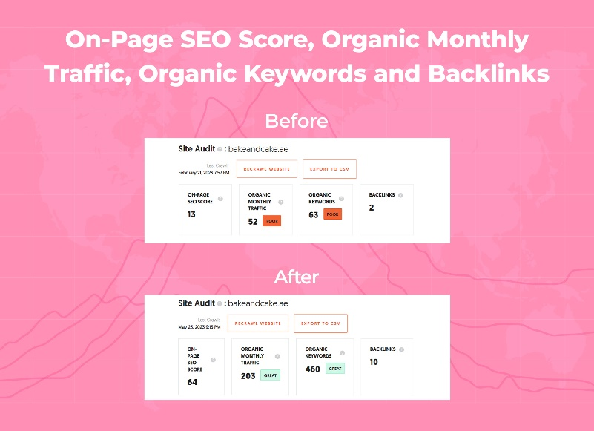

**Before:** The website had a low On-Page SEO Score of 13, accompanied by poor performance metrics including 52 monthly organic traffic, 63 organic keywords, and only 2 backlinks.

**After:** Following SEO implementation, the website experienced significant improvements, with an On-Page SEO Score of 64, impressive metrics such as 203 monthly organic traffic, 460 organic keywords, and an increased number of backlinks to 10.